SPETA PROCUREMENT BULLETIN
05 Jan 2026

SPETA would like to disseminate the following information to its members:

A newly setup company with HQ outside of Singapore, specialising in diaphragm regulator valves for different sectors including semiconductor, chemical processing, life sciences, water treatment and high purity gas systems is seeking prospective local partners to address their growing business needs:

S/N | Description of needs / challenges | Remarks
1 | Looking for precision engineering who is familiar with the requirements of semiconductor industry to produce the following.  Functional Requirement (e.g. dimensional, surface finishing, material handling, operating environment, etc.)
2 | PT1000 diaphragm  - SS 316: 100-piece pilot run, 30,000 production run  - Hastelloy: 100-piece pilot run, 10,000 production run | 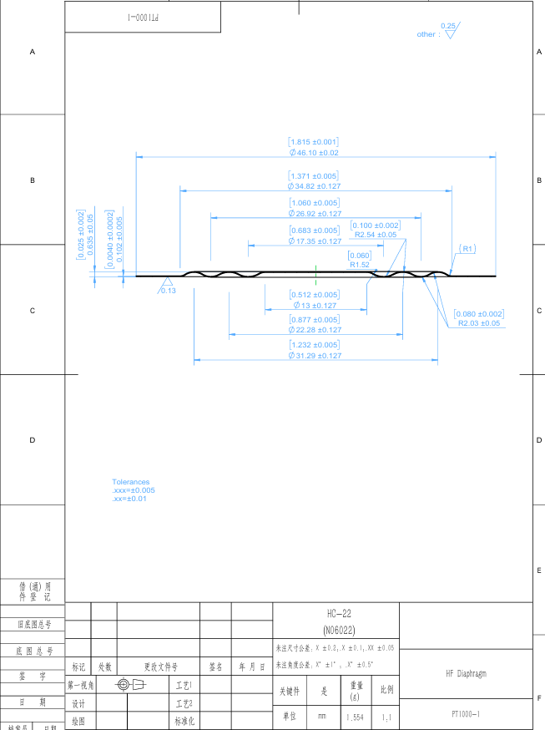
3 | PT1400 diaphragm  - SS 316: 100-piece pilot run, 10,000 production run  - Hastelloy: 100-piece pilot run, 10,000 production run | 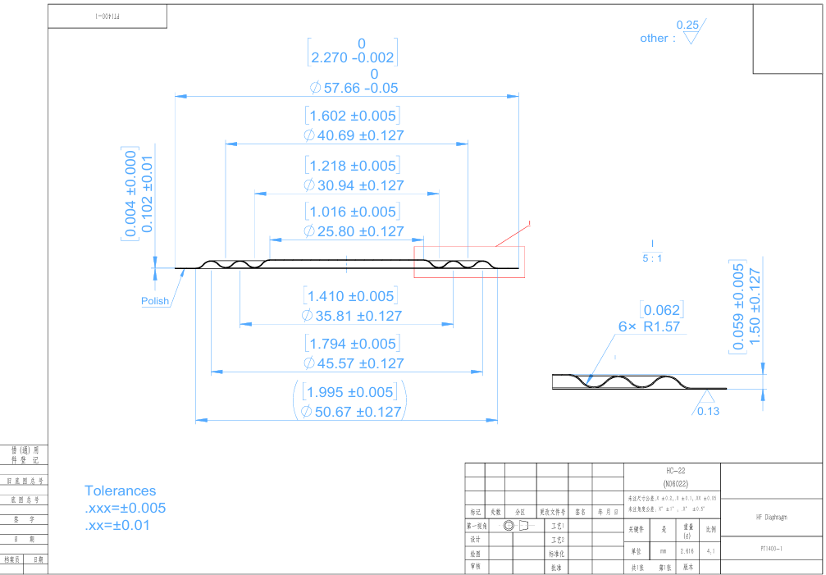
 | Requirements:  Material for both diaphragms  - SS 316: full hard, .004" thick  - Hastelloy: C22, full hard. .004" thick  - Full hard for the PT1000 size, ¾ hard for the PT1400 size.  - Raw material Ra: Roughness Ra＜0.13μm, No EP required.  Final production environment:  Class 1000 cleanroom  Supplier Requirement (e.g. industry certification, accreditation, quality systems, etc.) :  Manufacturer should be certified to ISO 9001 and 14001 | 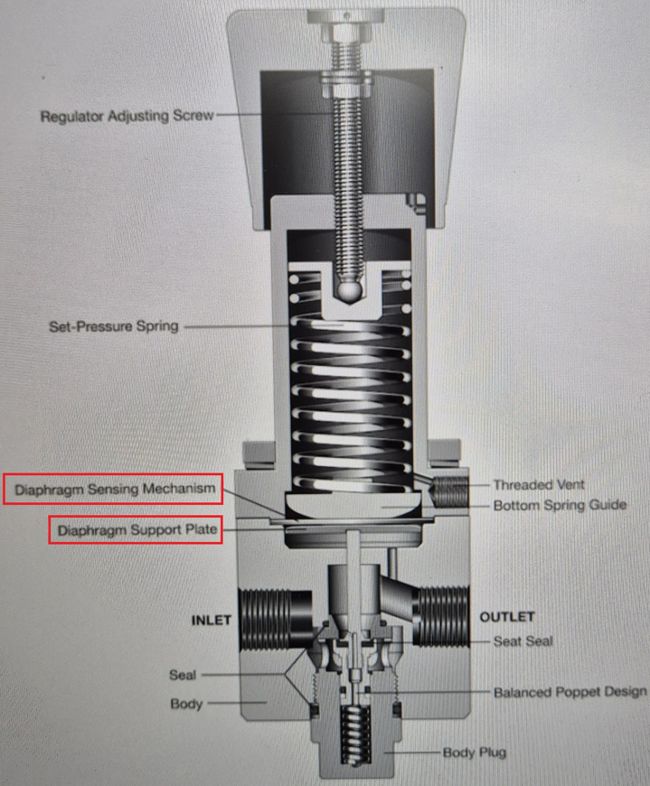

SPETA Member Input (Please describe how you meet the above requirements, and relevant past experience where applicable) :

--------------------------------------------------------------------------------------------------------------------------------------
Please submit your response via email with the following subject header “SPETA PROCUREMENT BULLETIN – 05 Jan 2026” to admin@speta.org by 23 Jan 2026, 12 noon.

The Enquirer will shortlist the prospective Partners and contact them directly.

Name of Member Co. : _______________________ _____________________________

Contact Person : _____________________________________________________

Designation : _____________________________________________________

Handphone and Email : _____________________________________________________

===

